Policy Memorandum
To: Commissioners, Public Service Commission of Wisconsin (PSCW) and Center for Waer Policy
From: Hadi Veisi, UWSP
Subject: A TNFD-Aligned Governance Framework for Large-Load Data Center Expansion in Wisconsin
Date: Feb 2026

Purpose
This memorandum presents findings from my recent statewide spatial assessment of 44 operational, proposed, paused, and cancelled data center facilities in Wisconsin and proposes a structured regulatory agenda aligned with the Taskforce on Nature-related Financial Disclosures (TNFD). The study evaluated biophysical risks (water stress, flood exposure), technological risks (grid and transmission capacity), and social governance risks (conflict intensity and procedural stress) using a standardized geospatial framework. composite and conflict risk maps are attached to support this briefing.
The central finding is structural:
Environmental and infrastructure risks are spatially differentiated across Wisconsin, yet permitting and incentive mechanisms remain largely uniform and reactive.

Key Findings Relevant to PSCW
The spatial analysis reveals three patterns that have direct regulatory relevance:

First, infrastructure exposure is concentrated in proposed hyperscale projects. Proposed facilities show higher transmission and grid stress indicators than operational sites. Cancelled projects cluster in transmission-constrained areas. This suggests that infrastructure feasibility is already functioning as a de facto filter—but only after projects advance, creating delay, uncertainty, and potential ratepayer exposure.

Second, biophysical risk is localized rather than statewide. While Wisconsin is not broadly water-scarce, watershed-level differentiation exists. Flood exposure also varies significantly across municipalities. National modeling shows that indirect water intensity—linked to electricity generation mix—often exceeds direct cooling consumption (Lei et al., 2023). This indicates that sustainability assessments must extend beyond facility boundaries to grid-level and basin-level analysis.
Third, social governance risk is spatially clustered. My conflict intensity mapping demonstrates elevated governance stress in municipalities hosting large-scale or early-stage projects. Social risk does not disappear once facilities become operational, suggesting that transparency, infrastructure cost allocation, and procedural engagement remain central concerns.
Together, these findings indicate that risk is geographically concentrated and lifecycle dependent.

Why a TNFD-Aligned Framework Is Appropriate
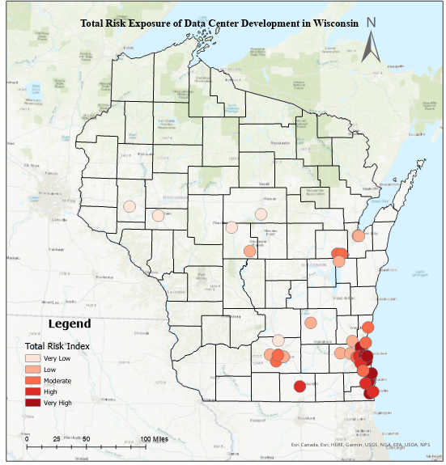
The TNFD framework (Locate–Evaluate–Assess–Prepare) provides a structured method to integrate spatial risk differentiation into governance systems. While designed for financial disclosure, its logic is directly transferable to regulatory review. Digital infrastructure is materially embedded in watersheds, transmission corridors, substations, and local governance systems. My composite risk maps demonstrate that these dependencies are measurable and mappable within Wisconsin. A TNFD-aligned approach would allow PSCW to formalize what is currently occurring informally—risk filtering through congestion and conflict—into anticipatory, transparent criteria.
Figure 1.Total Risk Exposure of Data Center Development in Wisconsin

Proposed Governance Agenda for PSCW
I recommend that PSCW consider development of a Risk-Aligned Large Load Review Framework incorporating four components:
- Grid Capacity Certification
Require formal verification of transmission and substation adequacy before final approval of large-load interconnections. Where capacity is constrained, phased commissioning tied to infrastructure upgrades should be required.
- Watershed-Level Screening
Integrate basin-level water stress and indirect electricity water intensity into environmental review. Projects in moderate-to-high stress areas should trigger enhanced mitigation or cooling requirements.
- Renewable Alignment Mechanism
Condition approval of hyperscale facilities on demonstrated renewable matching or additional capacity proportional to projected load growth. Comparative state analysis shows that expansion frequently outpaces renewable scaling (Kovacevic, 2025).
- Standardized Resource Disclosure
Mandate annual facility-level reporting of electricity consumption, water withdrawals, and cooling configuration to enable cumulative modeling and transparency.
These measures do not restrict investment. They increase regulatory predictability and protect grid reliability and water resilience.
Strategic Importance
AI-driven digital infrastructure growth is accelerating nationally. Research indicates that sustainability outcomes depend on synchronized renewable deployment and grid modernization (Xiao et al., 2025). Where expansion precedes institutional alignment, other states have experienced congestion, rapid transmission investment cycles, and politicized conflict (Kovacevic, 2025).
Wisconsin is not yet in crisis, but clustering of proposed hyperscale facilities suggests early-stage concentration. The attached composite and social conflict maps illustrate where cumulative exposure is emerging. This is a window for anticipatory governance.

Conclusion
My study demonstrates that Wisconsin’s data center expansion is spatially differentiated across ecological, infrastructural, and social dimensions. Infrastructure constraints and community conflict are already shaping project outcomes, but through reactive mechanisms rather than structured thresholds.
Adopting a TNFD-aligned large-load review framework would allow PSCW to:
- Protect grid reliability
- Reduce ratepayer risk
- Integrate basin-level water considerations
- Increase transparency and regulatory clarity
- Position Wisconsin as a national model for balanced digital infrastructure governance
I would welcome the opportunity to present the full spatial risk analysis and discuss how this framework could be operationalized within PSC authority or Center for Water Policy.

